Joseph Silva Jr.

SNHU

CS 405: 2-3 M2 Buffer Overflow

11/07/2021

**Original Code Debug Results**

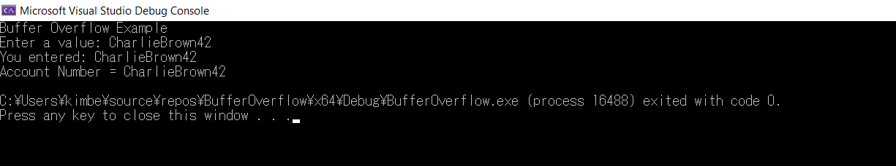

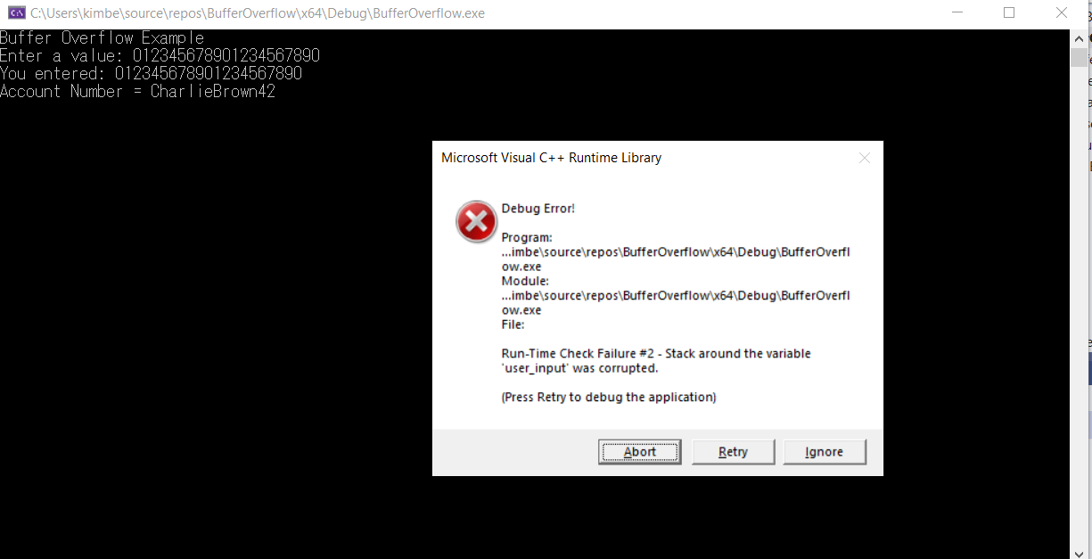

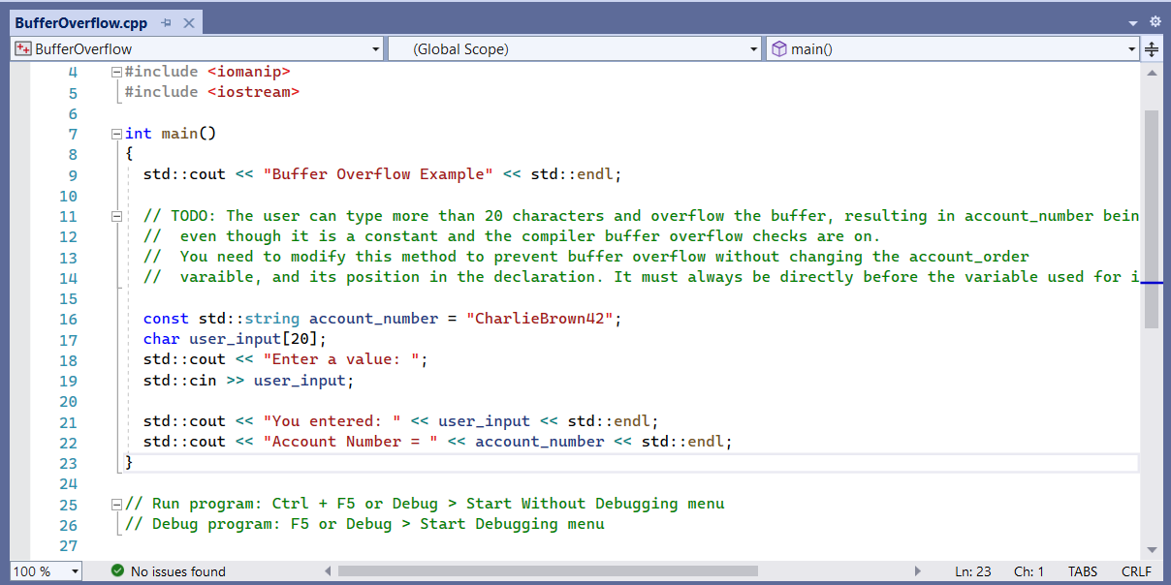

**Updated Code Debug Results**

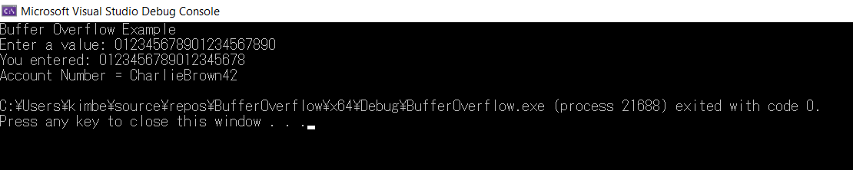

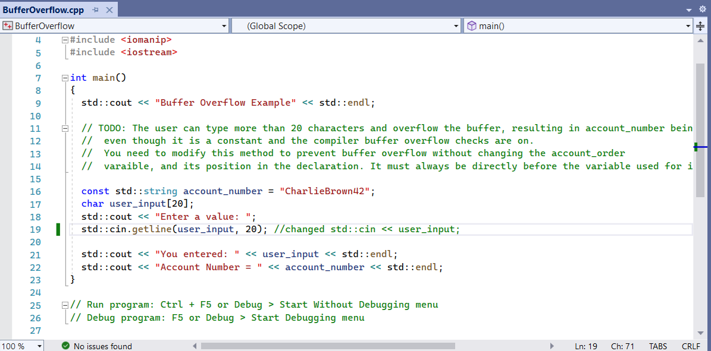

**Summary:**

For the BufferOverflow, I showed how the original code presented an error when a value had over 20 characters. When writing my original code, I reviewed the video “C++ Buffer Overflow…” and “Secure Coding…”. The first thing I did was replaced the code std::cin << user_input; which was under std::cout << “Enter a value :”;. For my first attempt of altering the code, I used scanf(“%s”, user_input); command. The scanf command which would read the formatted data from std and I used “%s” to read user_input as a string. This code came up with errors and my IDE told me to use the command scanf_s() instead of scanf() command. The scanf_s() command to read data from the input steam, but I also ran into errors with this command. I did research on different commands on which one would be useful to prevent an overflow due to a value input of over 20 characters. I was able to find the command of st::cin.getline() command from cppreference and this command allowed the program to retrieve the input value data, put the data into user_input, and then delim the value of the input to not go past 20 characters. This prevented any overflow from occurring and it also showed no issues found during the debugging of the program.